**Experiment 10**

**Create a data visualization (e.g., pie charts, bar graphs) for an inventory management system using javascript.**

**AIM:**

The aim is to create data visualizations, such as pie charts and bar graphs, for an inventory management system using JavaScript.

**Procedure:**

Step 1: Set Up Your HTML File

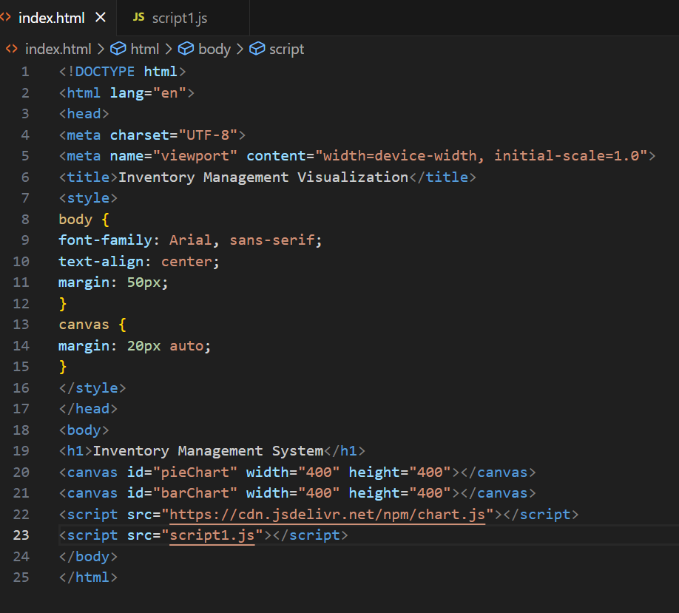

Step 2: Create the JavaScript File for Charts

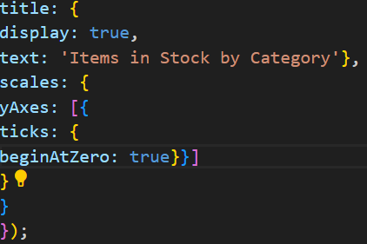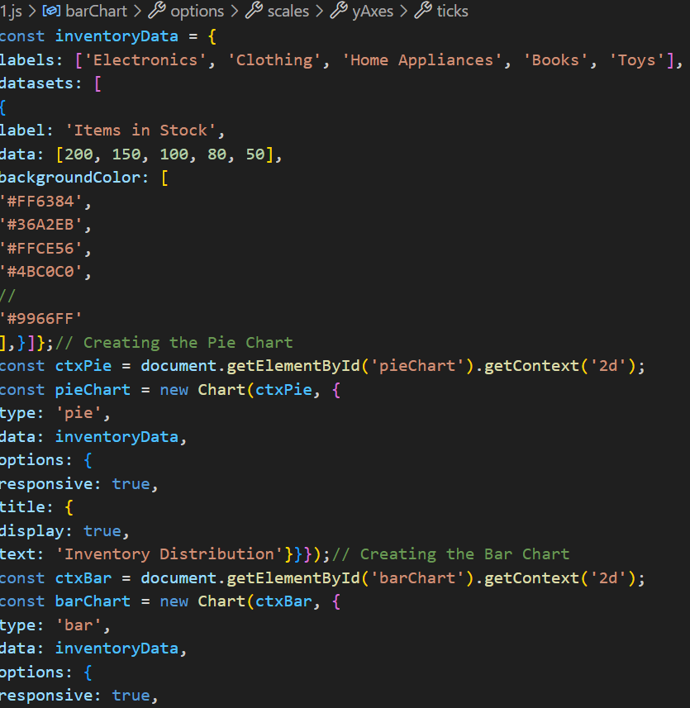

**Output:**

